|  |  |
| --- | --- |
|  | **engduino®**Tutorial  Engduino Support Team - support@engduino.org |

Setup guide for Engduino with MATLAB

# Introduction

The Engduino is a compact and portable microcontroller that has 4 built-in sensors to measure real world data for you to create interesting application of your own.

With the integration in MATLAB, you may use all the functions that exist in MATLAB to perform data analysis and visualisations with the sensor’s data from Engduino.

# Aims

This tutorial aims to provide a step-by-step guide for setting up Engduino with MATLAB. It will guide you through the download of required software and steps required to connect Engduino in MATLAB. Once, you have completed this setup, you can begin your development with Engduino in MATLAB, make use of the functions in MATLAB to create exciting application.

# Objectives

* Download the required software
* Configure Engduino to be discoverable MATLAB
* Connect to Engduino in MATLAB

# Learning Outcomes:

By the end of the tutorial, you should be able to

* Configure Engduino to make it working with MATLAB
* Able to connect to Engduino in MATLAB
* Start your development with Engduino in MATLAB

# Install Engduino IDE, configure Engduino to be discoverable in MATLAB

This tutorial assume that the user has no prior experience with Arduino-Engduino IDE. If you already have experience in Arduino-Engduino IDE, look at step 5 to locate the file that has to be uploaded to Engduino in order to make it discoverable in MATLAB.

1. Download and install Arduino-Engduino IDE for

Windows version:

<http://www.engduino.org/download/windows_installer_3264_bits/>

Mac version:

<http://www.engduino.org/download/mac_uncompressed/>

1. Once you have installed the IDE, launch it.
2. Turn on the Engduino and plug it into the USB port on the computer.
3. Launch the Arduino-Engduino IDE.
4. To make Engduino discoverable in MATLAB, we have to upload a **Protocol** to Engduino. Click **File->Examples->100.Engduino->Protocol**. This will open the Protocol.ino sketch. 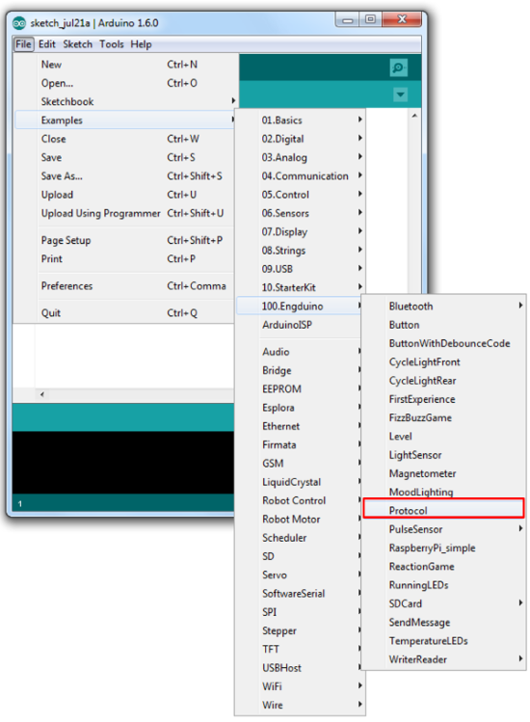
5. Ensure sure that you already know which COM port the Engduino is connected to, else launch the **Device Manager** on your computer to locate the port number as shown below. Engduino is listed as “Arduino LilyPad USB”. Note down the COM port number at the side. 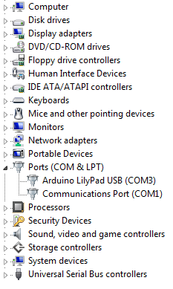
6. In Arduino-Engduino IDE, click Tools->Board->Select your Engduino version.
7. **Click->Tools->Port->**Select the port Engduino connects to
8. **Click->File->Upload** to upload the sketch to Engduino.

# Connect Engduino in MATLAB

1. Install the Engduino MATLAB Support Package and launch MATLAB.
2. Create a new script in MATLAB and run the following code to connect Engduino in MATLAB.

if (~exist('e', 'var'))

e = engduino();

end

1. You should see the following message in MATLAB command window.

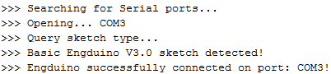

1. Alternatively, if the above method fails, you may try the following by giving the location of the Engduino hardware to MATLAB. Change the port number to which Engduino connects to.

if (~exist('e', 'var'))

e = engduino('COM3');

end

# Troubleshooting connection with Engduino

If you encountered issue with MATLAB not able to detect Engduino, and you can see that Arduino lily pad is listed in the device manager, please try to turn on/off, re-plug the USB to the computer. Restart MATLAB or your computer if the problem still persist.